SunSmart Newsletter Snippets

Protect your family – Download the SunSmart Global UV app
Sun exposure during childhood and adolescence is a critical factor in determining future risk of skin cancer—and the damage from UV radiation is cumulative and irreversible. Please take the time to ensure your children are protected whenever the UV is 3 and above to help reduce their skin cancer risk. Download the FREE SunSmart Global UV app from the app store to access the local daily sun protection times today.

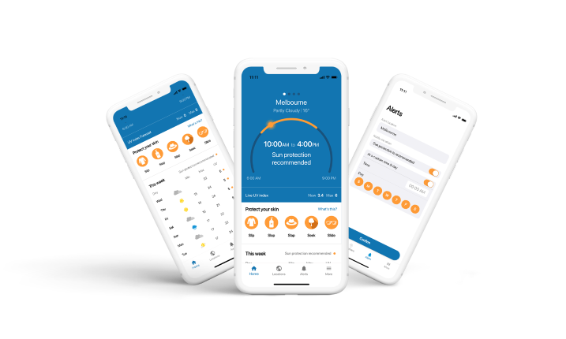

Did you know that a tan is a sign of skin damage?
A UV Index of 3 and above is strong enough to cause skin damage. A tan or sunburn is a sign of this skin damage, but sometimes this damage occurs without any visible changes. Damage from UV radiation adds up over time during our daily activities, often without us noticing, and contributes to skin cancer risk. Not sure what the UV index is, or when you should protect your skin? Check the daily sun protection times via the free SunSmart Global UV app, www.myuv.com.au or www.bom.gov.au. When the UV is 3 and above, protect your skin in 5 ways - slip, slop, slap, seek and slide.
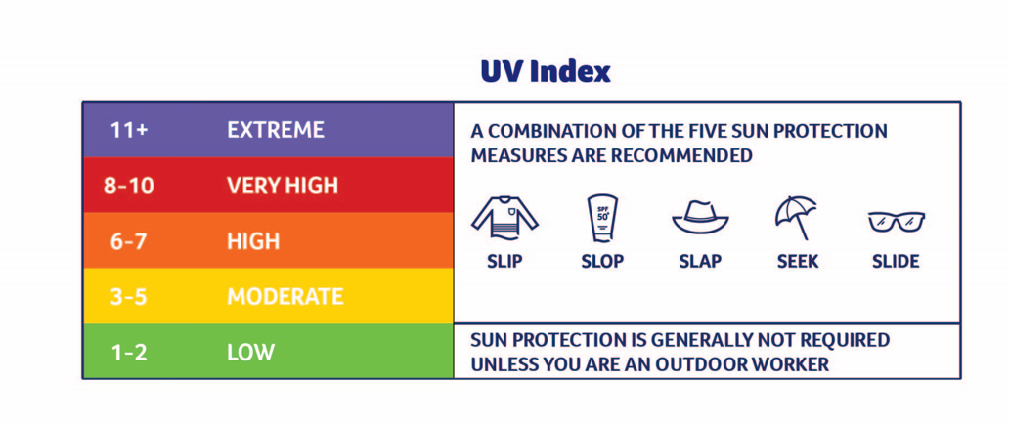

Think UV, not heat
Did you know UV radiation and infrared radiation are two completely different entities? Infrared is the heat we feel on our skin on a sunny day or when it’s hot, compared to UV radiation, which can’t be seen or felt, but is what causes sunburn and skin damage. UV is unrelated to temperature and UV levels are determined by a number of factors including: angle of Earth to the sun, time of day and time of year. UV levels can even be high on a cool and cloudy day. Check the UV level and protect your skin when the UV is 3 and above.

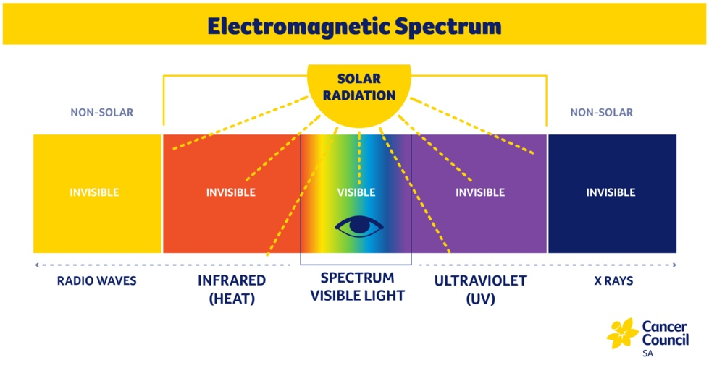

What is the easiest way to teach SunSmart behaviour?
Ensuring your child is protected from overexposure to UV radiation requires a team effort between families, education, and care settings. As a SunSmart school/centre/service, we are committed to ensuring your child is protected while in our care.
One of the easiest ways to teach children how to be SunSmart-is to show them. Role modelling sun protective behaviours as adults not only benefits children but saves our own skin too.
Please take the time to ensure you and your family are protected in five ways whenever the UV is 3 and above! To check the UV Index, you can download Cancer Council’s free SunSmart Global UV app.
Protect yourself in five ways:
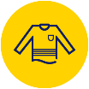
SLIP on sun-protective clothing

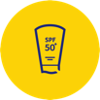
SLOP on SPF 50⁺ or higher sunscreen

SLAP on a legionnaire, broad-brimmed or bucket hat


SEEK shade

SLIDE on some wraparound sunglasses

How to correctly apply sunscreen
Use SPF 50⁺ or higher broad-spectrum water-resistant sunscreen; apply it 20 minutes before going outside and re-apply every two hours or after any activity that may remove it such as swimming, sweating or towel drying.
Cancer Council recommends that an average adult needs the equivalent of a teaspoon of sunscreen (about 5ml) for the face, neck and ears; a teaspoon for each arm and leg; and a teaspoon each for the front and the back of the body. Adjust this amount for children based on their body size.
It takes a few minutes to apply, but the benefits are long lasting. Whenever the UV forecast for the day is 3 and above (this generally translates to school terms 1, 3 and 4), apply sunscreen as part of your morning routine.
No sunscreen provides 100 per cent protection against UV radiation, so remember to also protect yourself by wearing protective clothing, a brimmed hat, sunglasses and by seeking out shade when you can.
Remember to store sunscreen at or below room temperature, and use it before its expiry date.
SLOP on SPF 50⁺ or higher sunscreen

Did you know…?
- A cap just doesn’t cut it. Skin cancer is most commonly diagnosed on the face, neck and ears.
- A SunSmart hat can reduce the amount of UV radiation reaching the eyes by 50 per cent. Makes sense to wear a shady hat, doesn’t it?
- Over 2,000 people die from skin cancer each year in Australia. Melanoma is the most common type of cancer diagnosed in young people aged 12-24 years.
When buying a hat for you and your family choose one of the following SunSmart hat styles:

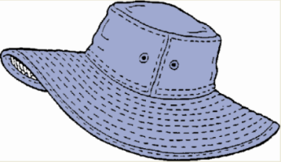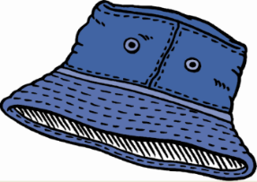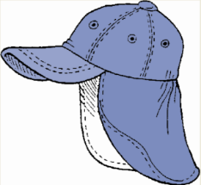
Broad-brimmed Bucket Legionnaire Style

What to look out for when choosing sun protective clothing
Sun protective clothing is included in the centre/school uniform/dress code.
Cancer Council recommends clothing is cool, loose fitting and made of closely woven fabric that covers as much skin as possible.
When shopping for clothing aim for the following:
- tops with collars or higher necklines, and longer style sleeves (at least elbow length)
- longer style dresses, skirts and shorts (at least knee length)
- rash tops for outdoor swimming
Keep in mind—the less exposed skin means less sunscreen application.
SLIP on sun-protective clothing

Time for sun protection and a skin self-examination
Two in three Australians will be diagnosed with skin cancer before the age of 70. The disease claims over 2,000 Australian lives every year, yet it is largely preventable.
When the ultraviolet (UV) radiation level is 3 and above, it is strong enough to damage unprotected skin. Don’t get caught out! You cannot see or feel UV, so you shouldn’t rely on the intensity of sunshine, or the heat you feel on your skin to guide sun protection. The only way to know if UV is 3 or above is to check the daily sun protection times. You can do this by downloading the free SunSmart Global UV app to your mobile phone, or by checking www.myuv.com.au or www.bom.gov.au. In South Australia, sun protection is generally required from the beginning of August to the end of April.
When UV is 3 and above:
- slip on sun protective clothing that covers as much skin as possible, but is also loose fitting and breathable
- slop on SPF 50⁺, or higher, broad spectrum, water-resistant sunscreen 20 minutes before going outdoors and reapply every two hours
- slap on a shady hat that protects the face, head, neck and ears such as a broad brimmed, bucket or legionnaire hat
- seek shade wherever possible and
- slide on wraparound sunglasses.
It is also important that we not only protect our skin from overexposure to UV radiation, but get to know our skin and check all areas regularly so early changes can be picked up. Most skin cancers are treatable if caught early.
Remember to check from head to toe, as melanoma can appear on areas of the body not normally exposed to the sun. If you are concerned about any spot on your skin, see your GP immediately.

What do you need to look out for?
- a new spot
- a spot that changes in colour, size or shape over weeks to months
- a spot that looks different to others around it
- a sore that doesn’t heal.

Know your ABCDEs for the early detection of melanoma.
Asymmetry – one half of the spot doesn’t match the other
Border – the spot has an uneven border
Colour – the spot has a mix of colours like brown, tan, black, pink or white
Diameter – anything larger than 6mm, have it checked however don’t wait if it looks suspicious
Evolution – the spot is changing in size, shape, colour or other traits.
For more information about being SunSmart view the video ‘Can you spot a skin cancer?’, visit sunsmart.org.au or call Cancer Council on 13 11 20.
